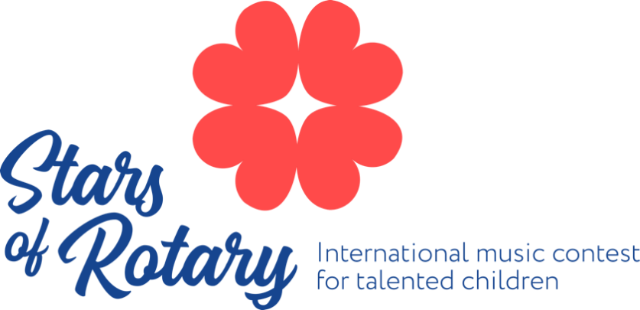

Contest Provisions and Regulations

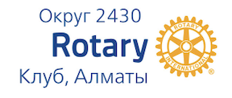
Regulations on the Conduct of the International Music Contest for Talented Child Performers on Piano, Violin, and Cello.

1. PURPOSE OF THE CONTEST

  - Bring the government’s attention towards the system of musical education in the country and the need to increase the number of music schools, as well as to update and replenish their funds and material possessions.
  - Provide support to young talented musicians and motivate their musical education.

- . GENERAL PROVISION

  - This provision governs the procedure for conducting the international music contest "Stars of Rotary" (hereinafter referred to as the "Contest") among talented child performers on piano, violin, and cello; requirements for entries, participants' ages; and the dates of the Contest.

  - The organizer of the Contest is the Rotary Club of Almaty, Kazakhstan. District 2430.

  - Children from two age groups may participate in the Contest: Group A - ages 7 to 9 years; Group B - ages 10 to 12 years.

  - For each age group, a separate application form has been developed. It is mandatory to fill them out in order to participate in the Contest. After filling out the application form and posting the contest video, participants will receive feedback on the results of the first online stage of the event. Those who advance to the second stage (Group B) will be invited to participate and perform live in Almaty.

  - The Contest consists of 2 stages: online and live (offline) formats. The stages are clearly regulated for each age group in Section 3 “Contest Stages” of this document.

  - The venue for the live stage of the Contest is in Almaty, Kazakhstan.

  - The Contest will take place from June 25th to June 30th, 2024.

  - To evaluate the competitors, the Rotary Club of Almaty has assembled an international-class jury. The jury is divided into 3 categories, one for each instrument: piano, violin, cello.

3. CONTEST STAGES

- For Group A (ages 7 to 9), the contest is conducted in an online format.
    - Performance duration should be between 3 and 10 minutes.
    - The program can be selected by the contestant or the teacher and should include 2-3 pieces. Only one-take live performances without editing are considered for evaluation.
    - Applications for Group A (ages 7 to 9 at the time of video recording) are accepted until March 10th, 2024, inclusive.
    - The results of the Contest will be sent out by April 10th, 2024.
    - The recording must be shared with a link to a YouTube/Telegram video or sent to the email address stars.of.rotary@gmail.com with the attached video file.
    - In the email title (subject line), it is necessary to indicate the surname and first name, date of birth, age, musical instrument, postal and email addresses, phone number, full name of the teacher, and a link to the video recording.
    - Alternatively, the application form can be filled out online through this link at the bottom of the webpage https://www.starsofrotary.info/application-form-7-9-years. The video can be attached through the application form.
  - For Group B (ages 10 to 12), the contest consists of 3 stages.
  - The First Round.
    - This round similar to the online format of Group A and will be evaluated by the jury based on video recordings.
    - The program can be selected by the contestant or the teacher and should include 2 pieces. Importantly, the pieces used in this round cannot be reused in the following rounds.
    - Performance duration should not exceed 10 minutes.
    - Applications for Group B (ages 10 to 12) are accepted until March 15th, 2024, inclusive.
    - The email submission process for Group B is identical to that of Group A described in paragraph 3.1.5-3.1.6 of this document.
    - Alternatively, the application form can be filled out online through this link at the bottom of the webpage https://www.starsofrotary.info/application-form-10-12-years. The video can be attached through the application form.
    - The results of the first round will be posted on the Contest’s official website before the end of March 2024.
    - Fifteen participants from each category will advance to the second round.
  - The Second Round
    - The contestants' live performances before the jury will take place in the city of Almaty, Kazakhstan, from June 25th to June 30th, 2024.
    - The performance should not exceed 15 minutes and should include:
For pianists:
1. Polyphonic piece.
2. Sonata, Sonatina (first, second, or third movements), or variations.
3. Etude or Virtuoso piece.
For violinists and cellists:
1. Etude or Caprice
2. Two pieces of contrasting character.
3.4.3 Five participants from each category advance to the third round.
  - Third Round
    - Contestants from all categories will perform a concerto with an orchestra (concerto of choice) - first, second, or third movements.
    - Important for violinists and cellists! - In the application, it is necessary to indicate whether a concertmaster is needed. The organizing committee provides a concertmaster (2 rehearsals of 30 minutes each) and one rehearsal with the orchestra for third round participants.
    - The contestants will be awarded based on the results of the third round.

- . AWARDS

  - For Group A (ages 7 to 9)
    - Contestants scoring 100 points will receive the Grand Prix and a diploma.
    - Contestants scoring between 93 and 99 points will receive the First Prize and a diploma.
    - Contestants scoring between 86 and 92 points will receive the Second Prize and a diploma.
    - Contestants scoring between 76 and 85 points will receive the Third Prize and a diploma.
    - The contest winners' diplomas will be emailed by April 10th, 2024.
  - For Group B (ages 10 to 12)
    - The Grand Prix - can only be awarded to one participant from each instrumental category. The winner for each category receives The Honorary Diploma of the Contest and a cash prize of $2000.
    - First Place - the Diploma of the Rotary International Kazakhstan Contest and a cash prize of $1500.
    - Second Place - the Diploma of the Rotary International Kazakhstan Contest and a cash prize of $1000.
    - Third Place - the Diploma of the Rotary International Kazakhstan Contest and a cash prize of $700.
    - Participants who take the fourth and fifth places are awarded diplomas.
    - The jury can award diplomas to concertmasters and orchestral musicians.
    - A special prize prepared by our partner - Steinway & Sons.
    - Additional prizes provided by our sponsors, the Ministry of Culture of the Republic of Kazakhstan, and various patrons.
    - The jury's decision is final and not subject to discussion!
IMPORTANT:
The contest schedule along with the provided dates and deadlines are subject to change. Amendments may occur due to technical reasons. We remind you to verify all the current information on the official website - https://starsofrotary.info
For inquiries regarding the contest, please contact:
Dilyara Mazhitova - Chairperson of the “Stars of Rotary” Executive Council, Rotary Club, Almaty.
Saule Tanekeyeva - Executive Director of "Stars of Rotary".
Altynay Beissembiyeva - Vice President of Rotary Club, Almaty. Past President 2019-2020, 2022-2023, Coordinator of "Stars of Rotary".
Natalya Drobysheva - Member of the “Stars of Rotary” Executive Council, Past President 2020-2021, Rotary Club, Almaty.
Stepan Shramko - Secretary of the Rotary Club, Almaty.

Alternatively, you can use one of the following means of communication:
Email - stars.of.rotary@gmail.com
Contact number -

